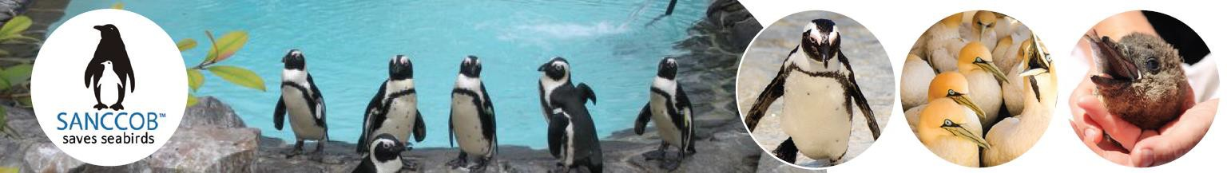

SANCCOB INDIVIDUAL MEMBERSHIP FORM
Being a Member of the Southern African Foundation for the Conservation of Coastal Birds (SANCCOB) makes you a valuable partner in our efforts to reverse the decline of wild seabird populations in southern Africa.
Have your say in shaping the future of our seabirds.

Due to the sensitive and impactful nature of SANCCOB’s work, membership rights are reserved at the discretion of the organisation.

AS A REGISTERED MEMBER, YOU WILL ENJOY THE FOLLOWING BENEFITS:

 | Voting privileges at SANCCOB's AGM (excluding  Junior Members). |  | Receive 10% discount at our souvenir shops AND an adoption certificate to “Adopt” and name an African Penguin.  Gqeberha Junior Members can attend a special event called the Little Blues Club Gathering, designed for young seabird enthusiasts.  Cape Town Junior Members participate in the Holiday Club Programme Day in June or December, providing an engaging educational experience.
 | Exclusive access to timely news updates from SANCCOB, keeping you well-informed about the latest news.
 | An annual tour for 4 at our Cape Town or Gqeberha centres, offering an immersive first-hand experience.
PERSONAL DETAILS:
Name & Surname
Phone number (Work)
(Mobile)
Email address
ID or Passport number
Nationality
Date of Birth
Postal address
Postal code |  | Country

MEMBERSHIP CONTRIBUTION STRUCTURE:
Type of membership | Fee | Tick box | Donation
Regular Membership | R 500
Senior Citizen | R 160
Junior | R 150 |  | Donation
 |  |  | Total
Send me more information about SANCCOB’s Legacy Programme
PROCESS FOR MEMBERSHIP:
- Please complete the application form and submit to: marketing@sanccob.co.za. Please note that your application will be treated with the strictest confidentiality.
- An invoice will be submitted to you for payment. Please submit proof of payment to marketing@sanccob.co.za.
- You will receive your membership certificate once payment has been received.

